Lab 3 - Storing artefacts

We'll have a look at creating some builds here, focusing on build step configuration, statuses and storing artifacts.

1. **Create a Job**

First, we will need a new Jenkins job to work on: create one called "Lab-3".

1. **Add a Build Step**

Let's add a build step that we know will succeed. Select the Add build step button and add an Execute shell build step.

Add the following script into the Command field:

**#!/usr/bin/env bash**

echo "Hello from the Jenkins job named: ${JOB_NAME}"

1. **Run the Job**

Save the job and then build it; you should then have one successful build in your history for that job.

Once you navigate to the console output, you should see an output like this:

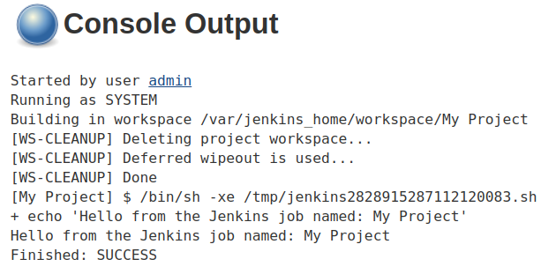

1. **Make the Build Fail**

Now that the last build succeeded, let's see what a failed build looks like!

All we have to do is make it so that the script we added to the command box "fails".

Jenkins will treat any script or application exiting with a non-zero status as a failure.

So to create a failed build, let's add exit 1 to the script box, which will make the script exit with a code of 1:

**#!/usr/bin/env bash**

echo "Hello from the Jenkins job named: ${JOB_NAME}"

exit 1

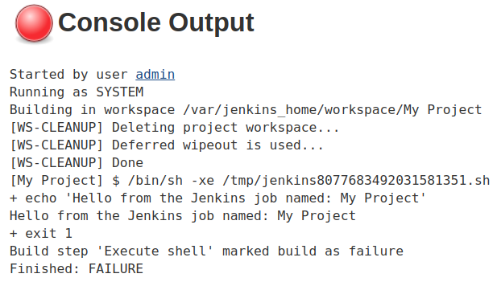

1. **Fix the Build and Create Artefacts**

We can, of course, remove the exit 1 from the build step to fix it.

After that, let's change the script to create several files, and then put them in a zip archive called archive.zip:

**#!/usr/bin/env bash**

echo "Hello from the Jenkins job named: ${JOB_NAME}"

touch 1.txt 2.txt 3.txt 4.txt 5.txt

zip archive.zip *.txt

Next, a Post-build Action must be configured to archive the zip files, using the "archive the artefacts" step type.

1. **Finish Up**

Now try to run the job. You should see artifacts on the project dashboard. If they don't show up, try refreshing the page.